MAPLD Panel Session


"Why Are Space Stations So Hard?

A Discussion of the Technical, Programmatic, and Political Factors That Have Lead To Successes and Failures Over the Last Three Decades and Implications for Future Private Sector and Government Facilities

Dr. Roger Launius -- Historical Perspective and Panel Moderator:
Chair, Division of Space History
National Air and Space Museum

Panel Members

Eric Anderson | President and CEO  Space Adventures, Ltd.
Keith Cowing | Editor, NASA Watch
Alphonso Diaz | "Member of the NASA Senior Staff; formerly the Associate Administrator," NASA Headquarters
William Dwyer | Engineer, Freedom and ISS  NASA Johnson Space Center
Rick Tumlinson | Founder, Space Frontier Foundation

Roger D. Launius

Division of Space History
National Air and Space Museum

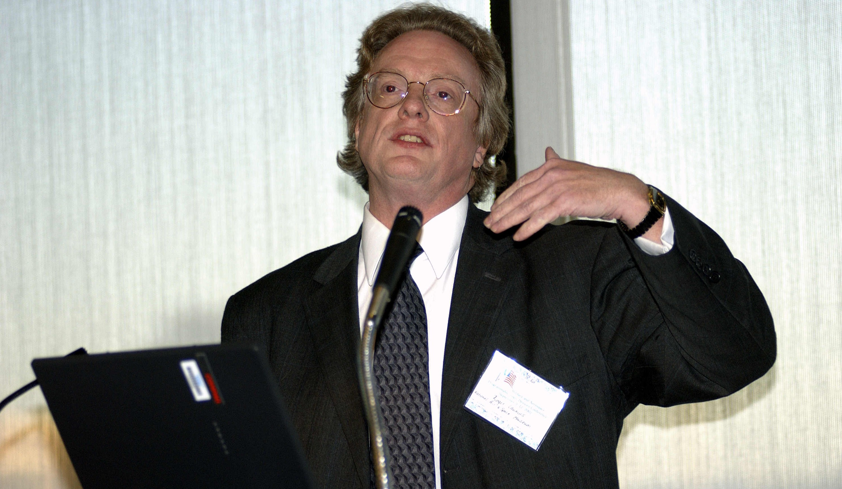

Biography

Roger D. Launius is chair of the Division of Space History at the Smithsonian Institution’s National Air and Space Museum in Washington, D.C. Between 1990 and 2002 he served as chief historian of the National Aeronautics and Space Administration. A graduate of Graceland College in Lamoni, Iowa, he received his Ph.D. from Louisiana State University, Baton Rouge, in 1982.

He has written or edited several books on aerospace history, including Space Stations: Base Camps to the Stars (Smithsonian Books, 2003), which received the AIAA’s history manuscript prize; Flight: A Celebration of 100 Years in Art and Literature (Welcome Books, 2003), edited with Anne Collins Goodyear, Anthony M. Springer, and Bertram Ulrich; To Reach the High Frontier: A History of U.S. Launch Vehicles (University Press of Kentucky, 2002), with Dennis R. Jenkins; Imagining Space: Achievements, Possibilities, Projections, 1950-2050 (Chronicle Books, 2001), with Howard E. McCurdy; Reconsidering Sputnik: Forty Years Since the Soviet Satellite (Harwood Academic, 2000), with John M. Logsdon and Robert W. Smith; Innovation and the Development of Flight (Texas A&M University Press, 1999); NASA & the Exploration of Space (Stewart, Tabori, & Chang, 1998); Frontiers of Space Exploration (Greenwood Press, 1998); Spaceflight and the Myth of Presidential Leadership (University of Illinois Press, 1997) with Howard E. McCurdy; Organizing for the Use of Space: Historical Perspectives on a Persistent Issue (Univelt, Inc., AAS History Series, Volume 18, 1995); and NASA: A History of the U.S. Civil Space Program (Krieger Publishing Co., 1994).

His interests and hobbies include baseball, ranting about politics and religion, and movies. He is also undertaking research to find the "perfect margarita." His favorite quote of late is, “non illegitimi carborundum.”

Eric Anderson

President and CEO
Space Adventures, Ltd.

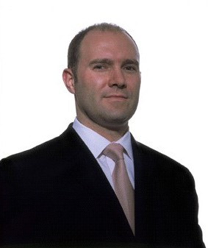

Biography

Eric C. Anderson is one of the leading entrepreneurs in the commercial human spaceflight and space tourism industry, an astropreneur (as coined by Wired magazine). As the president and CEO of Space Adventures, Ltd., Mr. Anderson has led the world’s premier space tourism company to several years of profitable success and has sold more than $100M in spaceflights; including the first and only two space tourists to fly to the International Space Station (ISS); Dennis Tito and Mark Shuttleworth, and the most recent orbital mission candidate, Gregory Olsen, Ph.D., who is currently in spaceflight training. Mr. Anderson co-founded Space Adventures in 1998 with several former astronauts and leading visionaries from the aerospace, adventure travel and entertainment industries.

Mr. Anderson’s vision is to open the space frontier to private citizens, and to develop and utilize space resources for the benefit of humanity on Earth. He has been and remains an outspoken advocate of commercial space transportation, private space exploration and space tourism. Through the development of innovative programming that includes the company’s continued launches of commercial passengers to the ISS and via future suborbital spaceflights, Space Adventures has created a paradigm providing spaceflight opportunities to all private citizens. Mr. Anderson believes that space exploration is vital to human progress and that by opening the space frontier, we can greatly enhance technological development and cultural understanding in a variety of areas.

Previously, Mr. Anderson was the principal and co-founder of Starport.com which was sold to SPACE.com in June 2000. Mr. Anderson also worked as a business development lead for Analytical Graphics, Inc., the leading aerospace software firm; and has held various consulting and research positions with NASA, where he authored several technical papers and articles, on topics ranging from space tourism to launch vehicle analysis to business and economic evaluations of various space-related ventures. He is also a guest speaker and lecturer on various topics within the aviation/aerospace and travel industries. Mr. Anderson graduated magna cum laude from the University of Virginia, with a bachelor’s degree in aerospace engineering, and was selected by USA Today as one of the nation’s Top 40 graduating seniors of 1996.tev
Keith Cowing

Editor, NASA Watch

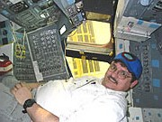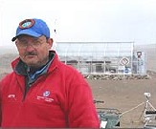

Biography

Keith Cowing, Webmaster, astrobiologist, journalist, former rocket scientist, and recovering ex-civil servant.
Keith Cowing is trained as a biologist (M.A. and B.A. degrees) and has a multidisciplinary background with experience and expertise that ranges from spacecraft payload integration and biomedical peer review to freelance writing and website authoring.

Keith is editor and webmaster of the somewhat notorious NASA Watch, an online publication devoted to the free and uncensored exchange of information on space policy and NASA operations. This website is read regularly within NASA, Congress, and the global space community. Keith is also editor of SpaceRef.com an online space news and reference resource he runs with his business partner Marc Boucher.

Keith has appeared many times on television and radio including ABC, CBS, NBC, MSNBC, Fox, NPR, CNN, PBS, CBC, CTV, Discovery Channel Canada, NHK, BBC, Travel Channel, Tech TV and has been quoted in a number of newspapers and magazines ranging from Wired and the Washington Post to the Economist and Pravda, among others.

Keith has written a book with fellow journalist Frank Sietzen "New Moon Rising: the Making of America's new space vision and the remaking of NASA". This book chronicles President Bush's recently announced space policy and the process that led up to its development. Keith and Frank broke the news of Bush's new space policy in a series of exclusive UPI articles in January 2004. Keith and Frank are now working on a sequel titled "Uncertain Moon" which is due in bookstores by Christmas 2005.
Keith donated his time to serve as an organizer and later, as the proceedings co-editor, for the NASA Administrator's Symposium "Risk and Exploration: Earth, Sea, and the Stars" which was held at the Naval Postgraduate School in September 2004. The proceedings are now online and have been published in hardcover as a volume in NASA's history series.

NASA Watch has been cited as a news source multiple times in Congressional hearings by the Chairman of the House Science Committee. In 1998, as editor of NASA Watch, Keith was asked to submit testimony for hearings held on NASA's 40th Anniversary by the House Subcommittee on Space and Aeronautics. A portion of this testimony appeared on the 23 October 1998 editorial page of the Washington Post.

In addition to NASA Watch and SpaceRef, Keith is also editor of the Astrobiology Web and has been active in Astrobiology activities since the onset of this emerging discipline in 1996. Keith participated in the first Astrobiology Workshop in March 1996 and the Astrobiology Roadmap Workshop in July 1998 as a member of the Astrobiology focus group. Keith coauthored "Astrobiology at T+5 Years" with NASA Astrobiology Institute Director and Nobel Laureate Baruch Blumberg, which was published in Ad Astra magazine in 2002.
Keith was also the guest editor, contributing author, and lead illustrator of three special issues of the National Space Society's magazine "Ad Astra": two issues on Astrobiology (Jan/Feb 1999 and Jan/Feb 2002), and one on terrestrial Mars analogs (May/June 2003).

Being a former NASA employee, Keith has been itching to get back into some hands-on space related research. As such, Keith has become involved with the NASA Haughton Mars Project (HMP), an ongoing research activity conducted on Devon Island in the Canadian high arctic less than 1,000 miles from the North Pole. Keith and his SpaceRef business partner Marc Boucher donated an experimental greenhouse which they constructed on Devon Island in the Summer of 2002. A journal of Keith's month-long experiences on Devon Island during 2002 can be found online here. Keith returned to Devon Island for another month in 2003 (journals).

In addition to the Astrobiology Web and NASA Watch, Keith is also webmaster of Science.Bio.org sponsored by Biotechnology Industry Organization (BIO).

Previous Experience

While employed at the American Institute of Biological Sciences (AIBS), Keith managed various peer review contracts, including the FY 94 and FY 95 peer reviews for NASA's Office of Life and Microgravity Science and Applications. Keith also had a senior management role in the AIBS review of 2,668 proposals for the Army's 1994 Breast Cancer Research Project, the largest single peer review project ever performed by or for the Federal government.

Between 1990 and 1993, Keith was a NASA civil servant and served as Manager of Pressurized Payload Accommodations at the Space Station Freedom Program Office (SSFPO). As part of his prime responsibilities, Keith served as the Payload Accommodations Manager for the 2.5 Meter Centrifuge Facility, the Gas-Grain Simulation Facility, the Gravitational Biology Facility, and the CELSS Test Facility. Keith also participated in all SSF design reviews held during 1990-1993, representing the interests of the scientific payload community. Keith was also the SSFPO lead on biospecimen containment and was a NASA representative to the NRC Committee on Toxicology's subcommittee on Spacecraft Maximum Allowable Concentrations.
Prior to his work at NASA, Keith worked for AIBS on NASA Life Sciences Division Peer review and for the Universities Space Research Association (USRA) where he managed a subcontract in support of the NASA Life Sciences Strategic Planning Study Committee (a.k.a. the Robbins Committee). Keith is also a former member of the governing board of the American Society for Gravitational and Space Biology (ASGSB). Keith also designed the ASGSB logo which adorned t-shirts worn by crew members on both STS-40 and STS-58 and by NASA scientists in Antarctica. Keith managed to wear one years later in the arctic.

Keith has had several other "careers". He has worked as a certified sign language interpreter for the hearing impaired at several universities and signed various speeches from the podium of the 1980 Democratic National Convention; was an advance man, local organizer, and finance officer for Jerry Brown's 1980 Presidential campaign and the 1982 Brown for U.S. Senate campaign; taught biology and sign language on several college faculties; worked on the Space Shuttle Program at Rockwell International's Downey Facility, and served time as an art major (earning an undergraduate degree in Fine Arts).

At one time or another Keith's hobbies have included running, skiing, hiking, fossil collecting, SCUBA, and rock climbing (Keith and his wife Jenny met while climbing).

Keith has written several climbing-related articles. One of them, "Everest On-Orbit " was published in Climbing Magazine. Another, "Oh Mons! The First Ascent of Olympus Mons" was published in the National Space Society's Ad Astra Magazine (their first published fiction). Another climbing-related article "Roger Houston. On Belay" appeared in the Winter 1997 issue of Tranquility Base, the newsletter of the 2111 Foundation. Keith also wrote about a rather spectacular climb (at least he thinks so) in Rocky Mountain National Park called The Petit Grepon and a introspective travelogue called "Going Off Source: Time away with SETI in West Virginia"

Alphonso Diaz

"Member of the NASA Senior Staff; formerly the Associate Administrator" -- NASA Headquarters

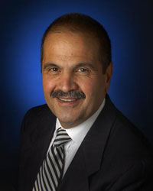

Biography

JAlphonso V. Diaz, now a member of the NASA Senior Staff, was appointed NASA's Associate Administrator of Science on Aug. 8, 2004. Previously, he had been serving as Director of NASA's Goddard Space Flight Center (GSFC) since Jan. 12, 1998. Prior to becoming GSFC's Director, he was the Deputy Director of Goddard from 1996. Before arriving at Goddard in 1996, Diaz was Deputy Associate Administrator for Space Science at NASA Headquarters from 1993 ? 1996.

As GSFC's Director, Diaz was responsible for planning, organizing, and directing NASA's Earth science, space science, and technology programs assigned to the Center. Goddard Space Flight Center is engaged in developing and operating scientific spacecraft. The Center continues to seek excellence in science and technology as demonstrated by many discoveries and advances in its history, from the first mapping of the Antarctic ozone hole to determining the very early structure of the universe.

From 1989 to March 1993, Diaz served as Deputy Associate Administrator and Chief Engineer of the Office of Space Science at NASA Headquarters. In that capacity, he was responsible for management direction and oversight of the space science flight program policy, launch vehicle requirements, technology infusion requirements, and mission study reviews and assessments. Diaz led the Agency committee charted by the Administrator to study proposals related to science institutes and to provide recommendations for implementation. Prior key positions with NASA include Deputy Associate Administrator for the former Office of Space Science and Applications (OSSA), Assistant Associate Administrator for Programs within OSSA, and Director for Strategic Plan and Programs for Space Station.

Diaz began his career at NASA's Langley Research Center in 1964. At Langley, he worked in a variety of technical management positions, principally on the Viking Project, GAS Chromatograph Mass Spectrometer. This scientific instrument was the first to analyze the surface material on Mars in 1976. In 1979, Diaz began his work at NASA Headquarters, where he served in a variety of positions. Aside from positions mentioned above, Diaz also has served as the International Solar-Polar Mission (now Ulysses Mission) Program Manager, the Galileo Program Manager, Manager of Planetary Advanced Programs, and as Deputy Director of the Solar System Exploration Division. He later served as Assistant Associate Administrator for Space Station within OSSA, managing all activities on the use of the planned Space Station for scientific research, and providing strategic planning guidance for OSSA's overall program of scientific exploration.
Diaz has received four Presidential Rank Awards; three as Meritorious Executive in 1990, 1995 and in 2003, and one Distinguished Award in 1996. He also received five Medals, a NASA Outstanding Leadership Medal for his work at the Goddard Space Flight Center in 2002 and 2004, an Exceptional Service Medal for his work at the Goddard Space Flight Center in 1999, a NASA Outstanding Leadership Medal in 1994 for his work on the Hubble Space Telescope First Servicing Mission, and an Exceptional Scientific Achievement Medal for his work on the Viking Project in 1977.

Diaz received a Bachelor of Science in Physics from St. Joseph's University in Philadelphia, Pa., and a Master of Science degree in Physics from Old Dominion University in Norfolk, Va. In addition, he attended the Massachusetts Institute of Technology (MIT) Sloan School of Management as a NASA Sloan Fellow and received a Master of Science in management in 1986.

He is an Associate Fellow of the American Institute of Aeronautics and Astronautics and is married to Angela Phillips Diaz. They reside in Takoma Park, Maryland.

William Dwyer

Engineer, Freedom and ISS
NASA Johnson Space Center

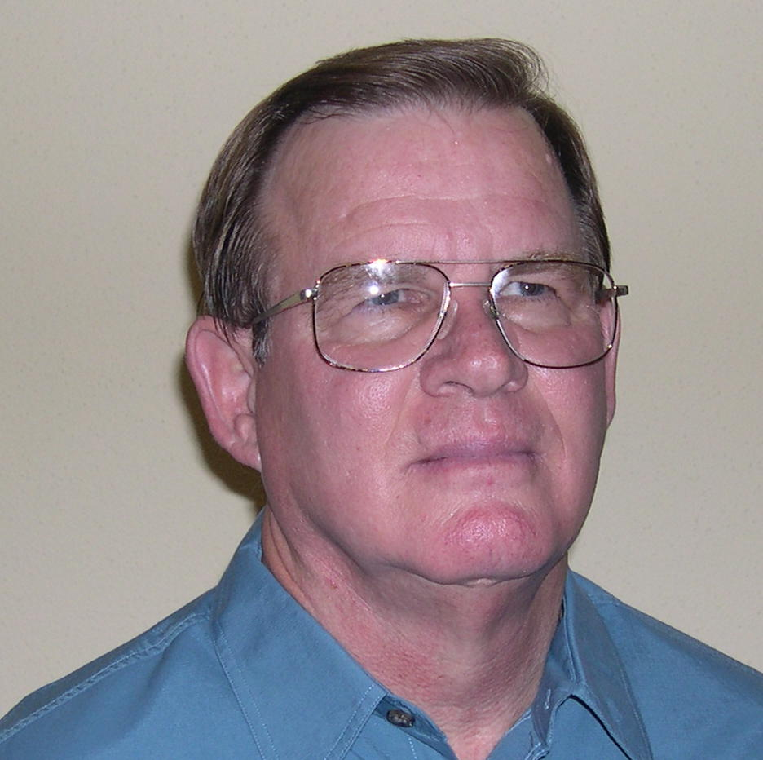

Biography

Bill Dwyer has been employed in the NASA, Johnson Space Center community since 1978, first working with Computer Sciences Corporation and Singer-Link Flight Simulation Division prior to jointing the JSC Civil Service community in 1987.

He served as the flight software integration manager during the Space Station Freedom program, participated in the space station transition and redesign and is now the System Manager for the International Space Station (ISS) command and data handling system (C&DH) hardware.

The C&DH hardware includes the general purpose flight computers onboard the ISS, called "multiplexer-demultiplexers" (MDMs) as well as the related ground hardware used to develop and test the flight software. Additional hardware in the C&DH inventory includes the payload high data rate routing and switching hardware for the fiber-optic networks.

Prior to his NASA and NASA contractor jobs, Bill was a communications officer onboard the aircraft carrier USS Forrestal (CVA-59) and taught at San Jacinto College in Pasadena, Texas.

Bill has a Bachelor of Science Degree in Mathematics from the University of North Texas and a Master of Science Degree in Mathematics from the College of William and Mary in Williamsburg, Virginia.

Rick Tumlinson

Founder, Space Frontier Foundation

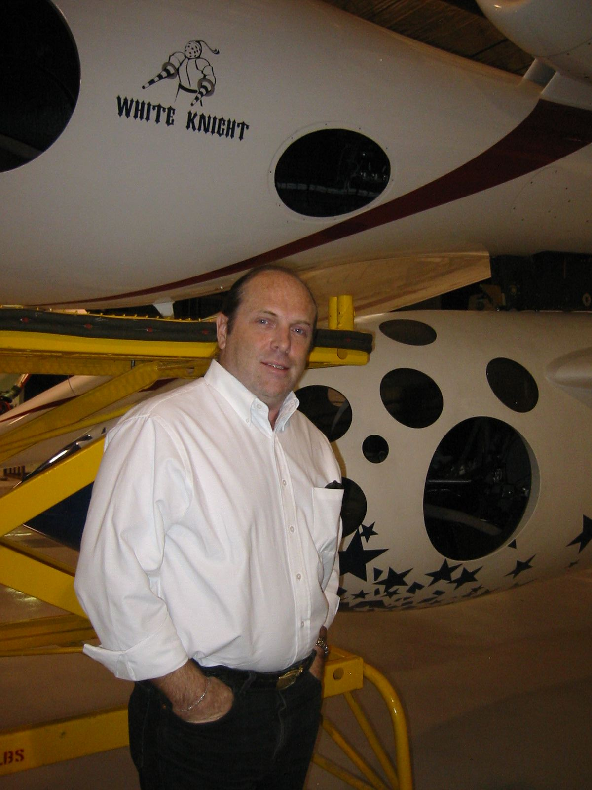

Biography

Named one of the world's top "Visonaries" and one the top one hundred most influential people in the space field by Space News, Rick Tumlinson is the Co-Founder of the Space Frontier Foundation, which has been called "pound for pound the most effective space organization on Earth." From an old Texas family whose pioneering credits include co-founding the Texas Rangers and fighting in the Alamo, Rick has spent his life fighting to open the space frontier. The son of an Air Force Sergeant and his English wife, he was educated primarily in England and Texas.

Mr. Tumlinson worked for noted scientist Gerard K. O'Neill at the Space Studies Institute, founded the New York L-5 Society, and was a key player in starting the Lunar Prospector project, which discovered hints of water on the Moon. He also helped pass the Space Settlement Act of 1988, testified before President Reagan's National Commission on Space, and was a founding trustee of the X-Prize. Over the years he has been a lead witness in six congressional hearings on the future of NASA, the US space program and space tourism, most recently in early 2004, testifying before Senator John McCain and the Senate Space and Technology Committee on the Moon, Mars and Beyond program.

Not satisfied to just talk, write about and help get funding for projects, Mr. Tumlinson has put his time and money where his mouth is. He co-founded the firm LunaCorp which produced the first ever TV commercial shot on the International Space Station for Radio Shack. He led the team which turned the Mir Space Station into the world's first commercial space facility, and was a co-founder of the space firm MirCorp. Along the way he personally signed up Dennis Tito, the world's first "citizen explorer," and has assisted in numerous other such projects.

Rick was also Executive Director and co-Founder of a foundation which funded breakthrough projects and activities such as Helium 3 research, laser launch studies, and asteroid processing projects. The organization provided the first $100k in seed money for the founding of the Mars Society, operated the Cheap Access to Space Prize and supported such projects as The WATCH asteroid search program. FINDS also underwrote and co-sponsored a very successful series of Senate Roundtables on space issues in conjunction with the Foundation and the lobby Pro-Space over the last few years. In the realm of education and inspiration, Rick Founded the "Permission to Dream" project, which has over the years placed dozens of telescopes in the hands of schools and educational groups around the world, from Sri Lanka to Iran and Russia.

To support his activism in his early years, Tumlinson produced the animated videos used to gain funding for the Air Force's DC-X rocket project, the International Space University, the X-33 rocket program, the Air Force's Space Command and created the first ever paid political announcement for space, which was featured on NPR's All Things Considered. A regular contributor to the space industry paper Space News Tumlinson's writings and quotes have appeared in the New York Times, Wall Street Journal, Los Angeles Times, Miami Herald, Reader's Digest and dozens of other publications around the world. He has appeared on such television programs as ABC's World News Tonight, the CBS Morning Show, and Politically Incorrect. Internationally he has appeared on TV sets from Russia to China's CCTV and the BBC and been quoted in a wide range of journals, from The Economist to China's People's Daily. Recently, Rick has appeared on the front page of the New York Times, has been featured in two issues of Popular Science, and appeared as an expert guest on the "CBS Evening News with Dan Rather," CNBC's "Open Exchange" and was quoted in papers such as the Washington Post, LA Times, and the Orlando Sentinel, regarding the Space Shuttle Columbia disaster. He also appears often as a space commentator on CNN.

In 2004 Rick was one of only 20 guests invited by the White House to hear President Bush announce his plans to return to the Moon and explore Mars. This year he joined NASA's prestigious Lunar Exploration Analysis Group, which will be laying out the framework for the first human outpost on the Moon and steps towards putting humans on Mars. He has also been a consultant to the Heinlein Prize Organization, and is working on a book which will be out this fall entitled, "Return to the Moon," and is starting his own space firm "XTreme Space."

Mr. Tumlinson is known as one of the best speakers in the field of space. His stirring and freewheeling talks range from critiques and discussions of current national space policy, to the presentation of a "Frontier" ideology for opening space, to the how and why of returning to the Moon, to a deeply spiritual discussion of our place in the universe, the search for other life and the reasons we are reaching for the stars.

